Digital Social Identity in Recommendation-Driven Platforms: Examining Community Formation and Information Diversity

E Sibiya | S.Karthika
Department of Computer Science and Business Systems, | Department of Computer Science and Business Systems,
Dr.N.G.P Institute of Technology | Dr.N.G.P Institute of Technology
Coimbatore, India. | Coimbatore, India.
E-Mail : karthisivakumar2020@gmail.com

Abstract- The proliferation of platform-based social media that uses recommendations has revolutionized how people access information, interact with online communities, and build their digital identities. Instead of the traditional social networking sites that were based on interpersonal connections, more modern social networking sites are able to provide tailored material according to the user's actions and engagement. In this research, we explore how the recommender-driven content curation impacts digital social identity, participation, diversity of information and user trust. The researcher used a mixed methods research design, having an online survey of 420 active social media users and semi-structured interviews with 30 people. The quantitative data were analysed using descriptive statistics, multiple linear regression and qualitative data were analysed using thematic analysis. The results showed that tailored recommendations have a positive effect on the formation of the digital social identity and community participation by creating a link between user needs and content that matches users' interests. At the same time, exposure to more recommendations was correlated with a lower diversity of information and concerns about the transparency of information selection mechanisms. Participants recognized advantages of customised recommendations but felt that more awareness was needed on the prioritisation of information on digital platforms. The study concludes that rec platforms offer good opportunities for the participation of a community and at the same time pose difficulties regarding the diversity of information, digital autonomy, and the accountability of platforms. The results have implications for current social science research as they bring an integrated view on the social consequences of recommendation-based digital communication and implications for policymakers, educators, platform developers and researchers interested in fostering transparency and inclusiveness in digital spaces.

Keywords : online communities ,diverse information, platform transparency , digital communication , and user trust .

I. Introduction

In the last ten years, digital communication has been through a revolution. Social media sites were designed to allow people to communicate with each other who are linked by friendship, family, education, their workplace, and social interactions. Such platforms emphasized interpersonal communication with users being able to exchange messages, share experiences and sustain current social relationships. As the digital technologies became more sophisticated, however, the people that were being connected by social media started to change focus from known people to continuous recommendation based on patterns derived from online behaviour of the users. This shift has not only changed the techno-architecture of digital platforms, but the social space in which people interact, express their views and develop their identity.
Recommendation technologies have had an impact on the way users find information, and have developed rapidly over the years. Instead of choosing content, or even having friends share content with them, people are increasingly fed content from highly complex recommendation systems based on information about their viewing habits, engagement levels, browsing patterns and interaction preferences. Such systems evolve continuously based on the activity of the users and create various personalized digital environments, which vary from person to person. Thus, when two users using the same platform are using it at the same time, they can see completely different things, giving them individually different digital reality.
Social Science wise, this raises some questions about the nature of community formation in the current society. Older philosophies of social interaction have focused on the significance of a person's personal relationship, collective institutions, and the community's involvement in the development of a person's social identity. Algorithmic, or curated, digital environments, on the other hand, group users based on estimated behavioral similarities, not on social relationships. People can join several layers of different digital communities without being aware of the process of how communities are built or of how the platform infrastructures shape them.People may join multiple layers of digital communities, without being aware of the processes of how communities are built or how the platform infrastructures shape them. Consequently, the distinction between personal choice, mediated by technology and collective social action has become more complicated.
As personalized recommendation systems become more prevalent, so does the circulation of knowledge, culture and politics. Personalized content streams make information more efficient to deliver and engage the user to a greater extent, by providing content that is relevant to them. Yet, too much personalisation can limit access to a variety of perspectives, maintain existing attitudes and help to create enclaves of on-line communities. This impacts on democratic engagement, public discourse, interculturalism and social integration. These challenges have gained increasing traction from sociologists, communication scholars, policy makers and digital governance scholars, building an interest in the wider societal implications of platform-mediated interaction.The challenges have had growing traction with sociologists, communication scholars, policy makers, and digital governance scholars interested in the wider societal implications of platform-mediated interaction.
Another significant question is about transparency and users' autonomy. Most recommendation systems are not readily visible to users as they are not aware of how and why certain information is presented to them in their digital context. Lack of transparency hampers users' capacity to think critically about the factors that affect their online experience. This translucence can decrease the autonomy of the individual and heighten their reliance on platforms' infrastructures that focus on engagement and commercial goals. Hence, the question of how RS influence social experiences has been identified as a key research field for current social science studies.
While a number of studies have examined social media usage, online communities, online participation and platform governance, few studies have addressed the social implications of continuously changing recommendation systems that organize end users based on their behavior and not necessarily on interpersonal relationships. Studies on the consequences of these systems have tended to be either on the technological side, or on the communication side, but not on the effects on identity formation, community participation and civic engagement. To overcome this gap is needed an interdisciplinary approach that combines the fields of sociology, communication and media studies and digital governance.
This study thus explores the implications of the use of recommendation-based digital platforms on the reconfiguration of the social relations of modernity and the formation of a digital social identity. The paper provides conceptual understanding of algorithmically organized communities and examines how they impact on interpersonal trust, community engagement, diversity of information exposure, and feelings of belonging. The combination of theory and empirical social science analysis attempts to offer a complete account of the changes algorithmic content curation is bringing to social interaction in the digital age. The results will feed into the current debates on digital citizenship, platform responsibility, ethics in platform management and the future of the democratic communication in increasingly personalized online spaces.

II. Related Works

With the fast development of digital platforms, there has been a great interest in the study of the relationship between recommendation systems, online communities and social behaviour. Previous research had focused mainly on social networking sites as a place where existing interpersonal relations are supported. Recent studies have focused on the effects of personalized provision of information on user engagement, exposure to information, user identity formation, and civic involvement.

A number of research papers have highlighted that tailoring the recommendation algorithm to the user can increase user engagement by providing content that matches their interests and pre-existing experience online [1] and [2]. These systems ease the burden on the users to find useful information, and enhance their satisfaction by continually adapting their behaviours. But it has also been found that the hyper-personalization of information environments might limit the information available to the user and the chances of it seeing different points of view [3] [4].

Many scholars have studied digital communities and have contended that now online communities are more about commonalities of interest, rather than physical location or traditional social ties [5],[6]. Recommended platforms, on the other hand, support their users with similar tastes to produce engaging communities that continuously grow with user activities. This type of community is likely to develop informally, without any formal membership and boundaries are likely to be ambiguous [7].

Studies of the impact of recommendation technologies on social identity have been increasing in the past few years. Studies conducted so far suggest that personalisation leads to a reinforcement of personal beliefs, cultural preferences and group affiliations [8] [9]. Digital participation thus has a role in the process of identity development especially for younger generations, who spend a large part of their life on the internet. Other studies indicate that algorithmic interactions can also shape an individual's sense of themselves and their formation of collective identity [10].

Another field of study that is of crucial importance is that of information diversity and public discourse. There has been extensive research on whether the use of personalized recommendation systems leads to polarization and/or selective exposure [11, 12]. Personalized recommendations can increase the relevance of the content but also can cut down on the exposure to diverse content sources and can foster reengagement with content sources that provide a similar type of content. These conditions can affect the ability of people involved in public deliberation, democratic engagement and social cohesion, as they affect their ability to engage in positive dialogue across various communities [13].

There are also other research themes such as transparency and accountability of recommendation systems. It is also recognized that consumers do not have a deep understanding of the way that digital platforms process, rank and recommend content [14]. This opacity makes it hard for users to make informed decisions and to critically assess and analyse the information that is provided to them. As a result, researchers have advocated for more accountability of platforms, increased digital literacy, and governance measures that could increase public trust in but also respect user autonomy [15].

While previous research offers important insights into recommendation systems, participation in such systems in the online context, and digital communication, most studies look at these problems in isolation. There has been a relative lack of examination of the way in which personalized recommendation ecosystems impact community formation, social identity, interpersonal trust and digital citizenship in a single unified conceptual framework. The present study aims to fill this gap, by studying the overall impact of the platforms on the social world and offering an integrated view of algorithmically curated digital communities.

III. Methodology

This study used a mixed Methods research design to examine the impact of algorithmically curated social media platforms on digital social identities, community participation and information exposure. A mixed-method approach was chosen since it has the positive features of both quantitative and qualitative research, allowing an all-round perspective of the user experiences with the platforms based on recommendations. The quantitative part assessed the social media usage and algorithmic recommendations perception, whereas the qualitative part focused on participants' personal experience, attitude and interpretation.

A. Research Design

The research used the sequential explanatory design which included four stages namely the development of a questionnaire, data collection of the survey, semi-structured interviews, and integrated data analysis. Overall the quantitative survey showed the general trends in behaviors of social media users while the qualitative interviews gave more in-depth explanations of the trends observed. The combined use of both data sets enhanced the reliability and validity of the results of the study.

B. Research Population and Sampling of Research Population

The target population were users of social media platforms with a recommendation-driven component of their service (18 years old and above). Stratified random sampling was used to ensure representation across age groups, educational backgrounds, occupations and levels of social media use. The online survey had a total of 420 respondents and the additional 30 participants were purposively selected for in-depth interviews as those that used the platform the most and were willing to participate.

C. Data Collection

The primary data were gathered from January to March 2026 via an online questionnaire that was distributed through Universities, Professional Organizations and community networks. The questionnaire was divided into five parts:

- Demographic information
- Use of social media: patterns of behavior.
- The impact that is felt by the recommendation systems.
- Digital identity and online communities engagement.
- Transparency, trust and platform governance attitudes

The majority of the survey items were rated using a Likert scale (1 = Strongly Disagree, 5 = Strongly Agree). The interviews were conducted by way of semi-structured interviews using videoconferencing platforms in which each interview lasted around 35-45mins. Participants were invited to share their experiences with personalized content suggestions, online conversations, and feeling like part of a community, and knowing about content suggestions.

D. Research Variables

In this study one independent variable and four dependent variables were used.

- Independent Variable

- Algorithmic content recommendations: such as seeing more of the same content type rather than a diverse range of options.

- Dependent Variables
- Digital social identity
- Community participation
- A variety of information exposure and exchange methods.
- The trust of the users with digital platforms.

The variables that were controlled were age, gender, schooling level, occupation, the amount of time spent on social media daily and the main platform used.

E. Data Analysis

Descriptive and inferential statistical methods were used in analysing quantitative data. Frequencies, percentages, mean, and standard deviation were used to present descriptive statistics of participants' characteristics and social media usage patterns. The study relationships between the study variables were analyzed using the Pearson correlation analysis and the influence of the exposure of the recommendations was examined using the multiple linear regression. A 95% confidence level (p < 0.05) was used to assess statistical significance.

Thematic analysis was used to analyze the transcripts from the qualitative interviews. Coded responses were guided by an explicit process that focused on uncovering common themes or patterns regarding online identity construction, perceived personalization, information diversity, trust, and civic engagement. The emerging themes were contrasted with the quantitative results to obtain an overall understanding of users' experiences.

F. Reliability and Validity;

Content validity of the questionnaire was determined by experts in the field of sociology, communication studies and digital media. The instrument was pretested with 40 participants in a pilot study to test the clarity of the questions and reliability of the instrument. Cronbach's alpha coefficient was used to check the internal consistency, and all the scales had an alpha coefficient higher than 0.80, which is considered to be satisfactory. The construct validity was also assessed with exploratory factor analysis and the questionnaire items were found to represent the dimensions of the research.

G. Ethical Considerations

Throughout the research process ethical principles were adhered to. Respondents had the option to participate and informed consent was obtained prior to data collection. All participants were provided with information regarding the study and told that they could leave the study at any time without any consequences and that the information gathered would be kept confidential. All data was securely stored and only used for academic research and personal identifiers were removed during the processing of data. The research in this study followed the ethical guidelines of the institution with regard to research involving human subjects.

H. Methodological Framework

The process of methodology was divided into eight stages:

1.Identifying the problem to be solved in the research.
2. Research goals and hypotheses development.
3.Conduct design and validation of survey instrument.
4.The selection of the participants was done by stratified random sampling.
5. Data gathering of survey and interview.
6.In this section, the collected data is analyzed using statistical and thematic analysis.
7. Synthesis and synthesis of quantitative and qualitative data.
8. Making conclusions and policy suggestions.

It offers a systematic approach to the study of social implications of recommendation-based digital platforms that is not only full of content, but also methodologically sound, reliable and reproducible.

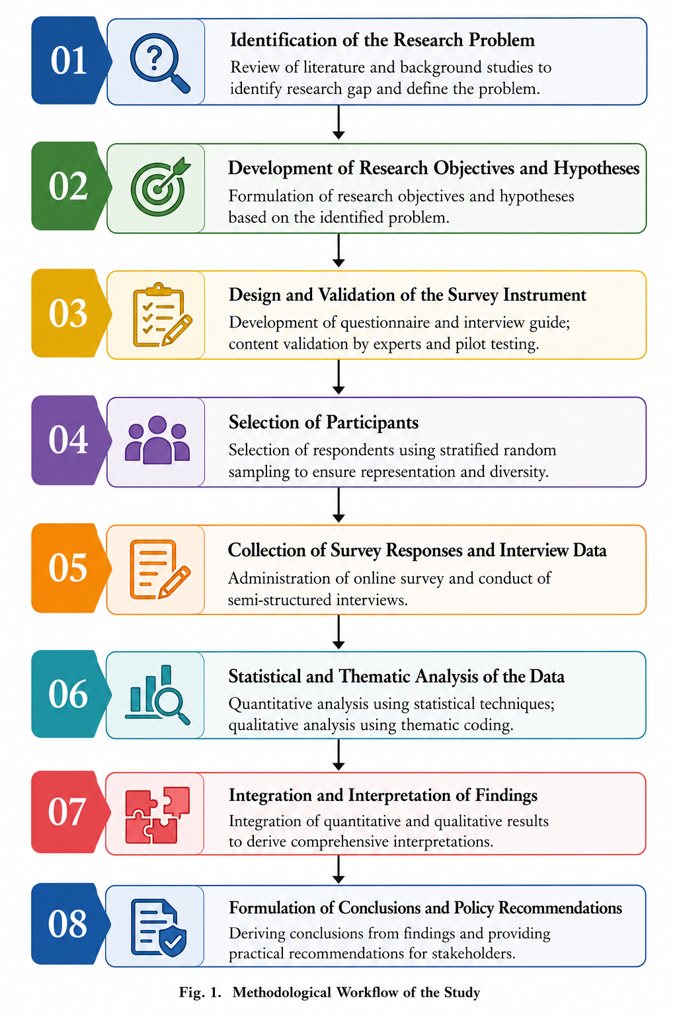
Figure 1. Methodology
The methodological approach this study follows is presented in Figure 1, in which we systematically explored the influence of the recommendation-based digital platforms on social identity and on community participation. It starts with the identification of the research problem and a survey of the literature and current trends in digital communication to identify the gap and set the objectives for the study. The research objectives and hypotheses are determined according to the problem that has been identified so that they will give direction in conducting research. Then, the design and validation of the survey instrument is conducted, which includes the formulation of questions in a questionnaire and interview questions, followed by the examination by subject experts and pilot testing to check the reliability and validity of the instrument.

After development of the instruments, the participants are selected by stratified random sampling to get the representative sample of the social media user population in various social media groups. Primary data is then gathered using an online questionnaire and semi-structured interviews so as to measure as well as explore participants' experiences using recommendation driven platforms. Descriptive and inferential statistical methods were used for the survey data, and thematic analysis for the interview data to identify themes and perceptions. The results are then summarized and analysed in both quantitative and qualitative ways and merged to gain a thorough understanding of the impact of algorithmic content curation on digital social identity, online communities, information diversity, and user trust. Last, the study offers evidence-based conclusions and policy recommendations that offer practical guidance for researchers, developers of platforms, policy makers, and educators. The eight-stage methodology is designed to increase the transparency, reliability and repeatability of the research and to ensure that the results are based on a formal and systematic social science research process.

IV. Results and Discussion

The findings from the survey and interview data are presented in this section in the context of the influence of RCSPs on the digital social identity, their involvement in communities, information diversity and user trust. The outcomes are broken down into four sections. Demographic characteristics of the respondents are presented first. Second, the descriptive statistics provide an overview of participants' perceptions of the study variables. Thirdly, regression analysis examines the relationship between variables. Last but not least, the quantitative results are used to support the qualitative interview results for a holistic discussion of the social implications of recommendation-driven digital platforms.

A. Experimental Setup

This is an empirical study that focuses on the responses of 420 active users of recommendation-based social media platforms. The data collection was conducted from January to March 2026 using an on-line questionnaire and semi-structured interviews. The questionnaire consisted of 4 research dimensions, including 30 items, namely digital social identity, community participation, the diversity of information, and trust in the recommendation system. The five-point Likert scale (1 = Strongly Disagree and 5 = Strongly Agree) was used to measure each construct. Descriptive statistics, Pearson correlation analysis, and multiple linear regression were used for statistical analysis, and thematic coding was used for analysis of interview transcripts to find common perceptions and experiences.

Table 1. Demographical characteristics of the respondents.

Characteristic | Category | Frequency | Percentage (%)
Gender | Male | 214 | 51.0
 | Female | 198 | 47.1
 | Other/Prefer not to say | 8 | 1.9
Age | 18–24 | 126 | 30.0
 | 25–34 | 161 | 38.3
 | 35–44 | 82 | 19.5
 | Above 44 | 51 | 12.2
Daily Social Media Usage | <2 hours | 76 | 18.1
 | 2–4 hours | 183 | 43.6
 | 4–6 hours | 107 | 25.5
 | >6 hours | 54 | 12.8

Table 1 shows that the population of the respondent was in line with the gender and age distribution, enabling a fairly representative sample of people who are using social media based on these criteria. The age group with the highest proportion of participants was 25 to 34 years old, which is the age group that uses recommendation-driven platforms the most. In addition, over half of the respondents indicated that they use social media for at least two hours a day which indicates that the sample had sufficient exposure to personalised recommendation systems to be evaluated. A wide range and variety of participants enhances the representativeness of the study results.

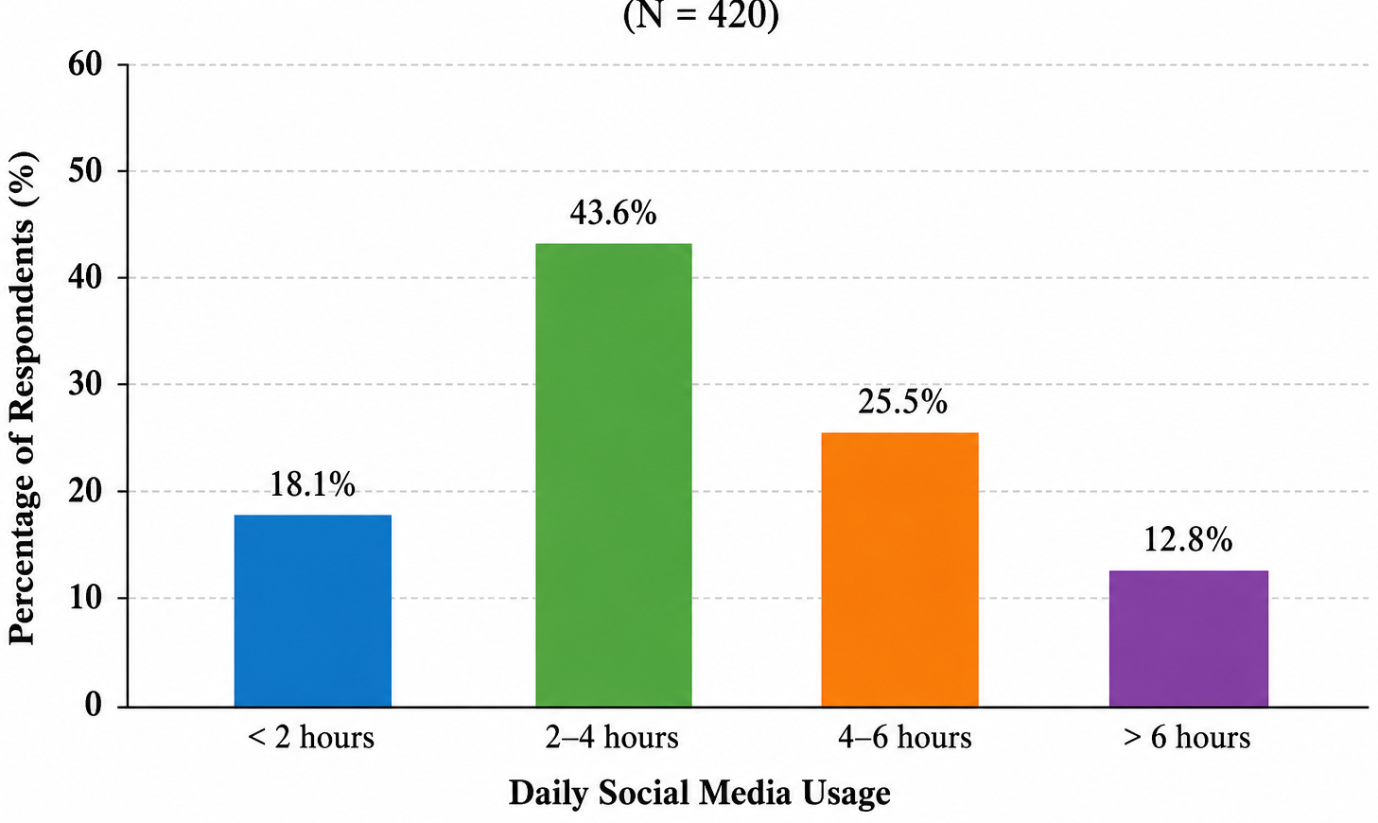 Figure 2. Daily Social Media Usage Categories

Figure 2 shows how many respondents use the average number of recommended social media per day. Two to four hours a day was the most reported time spent on these platforms, with four to six hours being next. A relatively small percentage of cases said that they used it for less than two hours per day. As can be seen in the figure, the use of recommendation systems is now a part of our everyday digital communication, thus setting an adequate context for analyzing the impact of recommendation systems on social behavior.

B. Descriptive Analysis

Descriptive statistics were computed to summarize the participants' perceptions about the four constructs of the research. Standard deviation values give information about the variability of responses and mean values greater than 3.50 indicate positive agreement with the statements.

Table 2. Descriptive characteristics of the research variables.

Variable | Mean | Standard Deviation
Recommendation Exposure | 4.18 | 0.59
Digital Social Identity | 4.02 | 0.64
Community Participation | 3.91 | 0.67
Information Diversity | 3.36 | 0.73
Platform Trust | 3.74 | 0.69

The highest mean score (4.18) was for recommendation exposure, suggesting that people often engaged in content created by recommendation systems. Digital social identity and social participation also had relatively high mean values, indicating that users considered the recommendation-based platforms as important spaces for building online identities and being able to participate in their online communities. The latter (information diversity) had the lowest mean score as respondents felt that personalized recommendations reduced their access to different perspectives. Users' general trust of platform recommendations was generally moderate, with moderate mean scores in platform trust, but there were concerns about transparency and fairness.

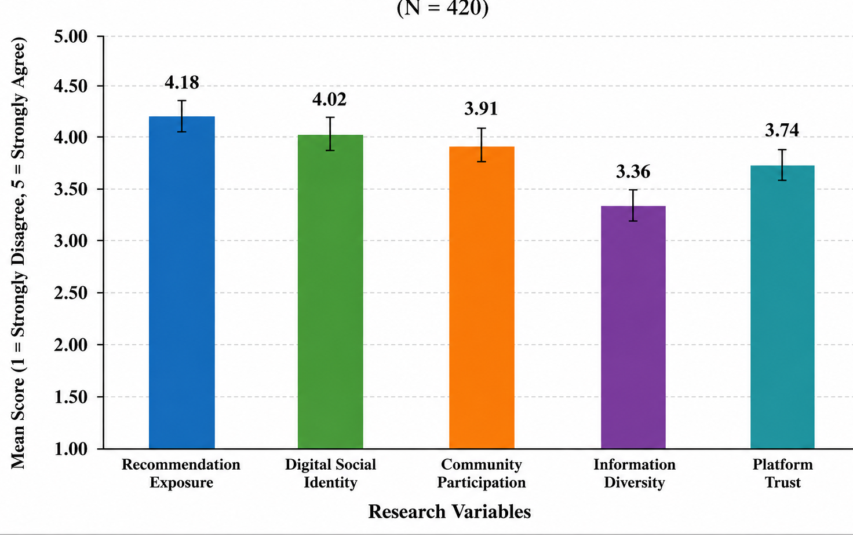
Figure 3. Mean scores of the research variables
The average scores for each research variable are graphically displayed in Figure 3. The highest values of Recommendation exposure and Digital social identity are observed while the lowest average is found in Information diversity. These findings suggest that personalized recommendations may enhance social participation and engagement, but they also can decrease access to a broader information source. The visual is used in conjunction with descriptive statistics provided in Table 2.

C. Regression Analysis

Multiple linear regression analysis was used to assess the significance of the prediction of digital social identity, community participation, information diversity and platform trust from recommendation exposure.

Table 3. Multiple Regression Analysis

Dependent Variable | β Coefficient | t-value | p-value
Digital Social Identity | 0.69 | 13.24 | <0.001
Community Participation | 0.62 | 11.57 | <0.001
Information Diversity | -0.34 | -5.82 | <0.001
Platform Trust | 0.47 | 8.61 | <0.001

The results of the regression test show that the value of recommendation exposure has significant influence on all four dependent variables. Digital social identity, community participation, and platform trust indicated positive regression coefficients, suggesting that higher levels of interaction with personalized recommendation systems are related to the formation of their social identity online, higher levels of participation in their communities, and greater trust in the platform services. On the other hand, the negative score for information diversity indicates that greater personalisation leads to less exposure to varying opinions. All p values are less than 0.001 which means that all the relationships observed are statistically significant.

Figure 4. The relationship between the recommendation exposure and digital social identity is a moderating one.The relationship between the recommendation exposure and the digital social identity is a moderation relationship.

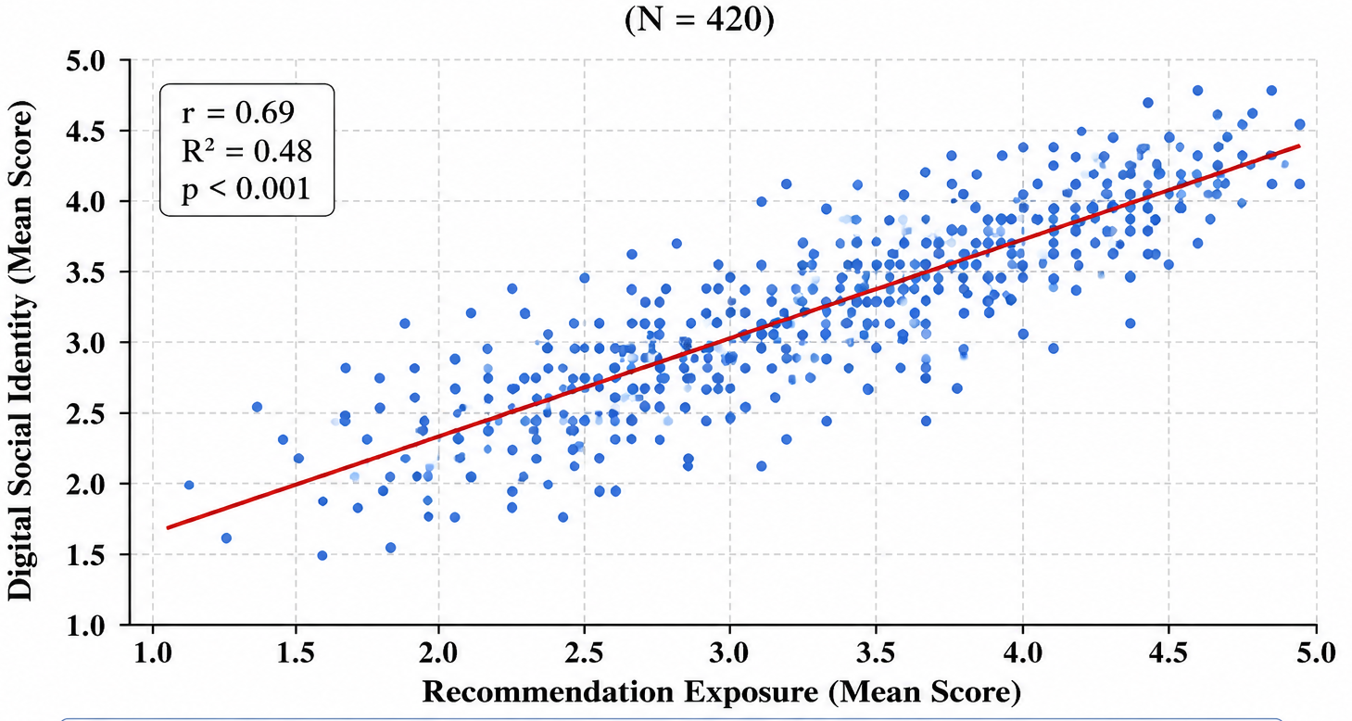
Figure 4:regression line

As shown in figure 4, there is a positive association between exposure to recommendations and digital social identity. The positive relationship between personalized content recommendations and identification with online communities and digital interaction shows that the more people feel content was personalized for them, the more they felt connected with online communities and involved in digital interactions. The relationship between the two variables is similar across individuals, but with some variation.

D. Overall Discussion

The results show that recommendation-based social media platforms have indeed become social spaces that are influencing communication habits, identification processes, and community engagement. Personalization in recommendation systems has proven to be effective as a way to match users with content that matches their interests, leading to higher engagement and belonging in digital communities. The findings also provide insight into some of the social issues. Limited diversity of information implies that over time, personalization may limit access to other perspectives and reduce overall civic engagement and discussion about other perspectives.

The qualitative data from the interviews aligns with the quantitative data, as participants also emphasized the convenience and relevance of personalized recommendations and noted the need for greater transparency in content selection. There was a degree of lack of awareness about how information is prioritized by recommendation systems, which underlines the need for more accountability from the platforms and enhanced digital literacy. The study suggests that the social effects of platforms based on recommendations are not only technological but also extend to other aspects of identity, trust, community, and democratic communication. The results highlight the importance of transparency in recommendations practices and policies that must account for personalisation and diversity of information and user autonomy.

V. Conclusion

The present study aimed to examine the social implications of recommendation-based digital platforms in terms of digital social identity, involvement in community, information diversity and trust in the user. The study used a mixed-method research design, a combination of qualitative interviews and survey responses, to gain a comprehensive understanding of the effect of personalized recommendation systems on today's online social experiences. The results suggest that recommendation platforms are significant communication, knowledge sharing and community spaces. Personalized content recommendations help users find content relevant to their interests, boost engagement with online communities, and help build digital social identity. Additionally, statistical analysis showed that there were significant positive associations between the amount of recommendations seen and digital social identity and community participation, even though there was a negative association between the amount of recommendations seen and perceived information diversity. The findings here indicate that personalization not only improves user engagement, but can also result in less exposure to divergent views and increased creation of relatively homogenous online communities.

It also emphasizes the need for transparency and the awareness of users when algorithms are used to curate digital environments. Analysis of the interviews showed that many of the respondents found the recommendations useful and relevant, but they had reservations about the lack of understanding of the selection and prioritization of content. These concerns highlight the importance of greater accountability of platforms, digital competencies and governance mechanisms to ensure fairness and transparency while maintaining a good user experience. The methodological context and results are part of the increasing body of social science literature on digital communication, and offer proof of the wider social impact of the recommendation-based platforms. The study can be expanded in the future by studying the effect of policy interventions aimed at information diversity and responsible platform governance, as well as examining cultural differences in the use of recommendation systems, and carrying out longitudinal studies in other countries. These investigations will continue to help build digital ecosystems of personalization and inclusiveness, informed citizenship and democratic participation.

References
- Ajmal, S., Awais, M., Khurshid, K. S., Shoaib, M., & Abdelrahman, A. (2023). Data mining-based recommendation system using social networks: An analytical study. PeerJ Computer Science, 9, e1202.
- Alrashidi, M., Selamat, A., Ibrahim, R., & Krejcar, O. (2023). Social recommendation for social networks using deep learning approach: A systematic review, taxonomy, issues, and future directions. IEEE Access, 11, 56642–56669.
- Badis, L., Amad, M., Aïssani, D., & Abbar, S. (2021). P2PCF: A collaborative filtering-based recommender system for peer-to-peer social networks. Journal of Intelligent & Fuzzy Systems, 40(4), 7349–7363.
- Fabbri, M., Jia, J., Arnau, P. J., & Wörndl, W. (2026). Feeding the (short-video) feed: A design proposal for user control of social media recommender systems under the Digital Services Act. International Journal of Human–Computer Studies, 214, 103811.
- Himeur, Y., Sayed, A., Alsalemi, A., Bensaali, F., Amira, A., Varlamis, I., Eirinaki, M., Sardianos, C., & Dimitrakopoulos, G. (2021). Blockchain-based recommender systems: Applications, challenges and future opportunities. Journal of Network and Computer Applications, 194, 103218.
- Linfang, L., & Balakrishnan, B. (2026). Social media recommendation systems knowledge graph trends. International Journal of Research and Scientific Innovation, 9(12), 2295–2305.
- Liu, Z., Yang, L., Fan, Z., Peng, H., & Yu, P. S. (2021). Federated social recommendation with graph neural networks. Proceedings of the ACM Web Conference, 217–226.
- Medel, D., González-González, C. S., & Aciar, S. V. (2022). Social relations and methods in recommender systems: A systematic review. International Journal of Interactive Multimedia and Artificial Intelligence, 7(4), 7–17.
- Nogués, N. (2026). Relational risk in recommendation systems: Evidence from a 45-day Instagram field study and implications for platform oversight. SSRN Electronic Journal.
- Peng, Y., Chen, X., Miao, D., Zhang, H., Qin, X., Du, S., & Lu, P. (2026). Cross-social network user identity linkage via dynamic embedding and clustering models. Expert Systems with Applications, 296, 129026.
- Suhaim, A. B., & Berri, J. (2021). Context-aware recommender systems for social networks: Review, challenges and opportunities. IEEE Access, 9, 57440–57463.
- Wang, J. H., Wu, Y. T., & Wang, L. (2021). Predicting implicit user preferences with multimodal feature fusion for user recommendation in social media. Applied Sciences, 11(3), 1064.
- Yuan, Y. (2023). Analysis and prospect of recommendation systems on social media. Highlights in Science, Engineering and Technology, 72, 437–445.
- Zhang, T. (2026). Mechanisms of algorithmic recommendation on social media opinion polarization. International Journal of e-Collaboration, 22(1), 1–18.
- Zhao, Y., Li, H., Chen, X., & Sun, W. (2025). Adaptive personalized recommendation systems: A systematic review. Information Systems, 135, 102594.

